



Technical Proposal Document
AMNS

Submitted on – 25 March 2025

Table of Contents
1 Proposed Solution 1
1.1 Our Understanding of AMNS’s Requirements 1
1.2 Scope of Services 2
1.3 Technical Scope 2
2 Overview of the process 2
2.1 Process Flow 2
2.2 Stagewise Action Points 3
3 Hardware for installations 5
3.1 Hardware List 5
4 Governance Structure 8
5 High Level View of Product Roadmap & Innovations Planned 9

Proposed Solution

Our Understanding of AMNS’s Requirements
Currently, AMNS is handling its entire mining operations manually right from the dispatch planning till the vehicles carrying the minerals reaches the Dabuna Plant. The entire mining operations involves the coordination and exchange of information and data at real-time between various government and local stakeholders at every stage of the process. The heavy reliance on manual processes and the lack of real time communication between the fragmented work flows and data silos is creating an inefficiency in the entire process.
Key Challenges in As-is process:
- Heavy reliance on manual processes at all the levels of the process.
- Lack of visibility on the Turn-around time at all the stages.
- Unnecessary delays across the stages because of manual processes
- Revenue losses owing to theft and pilferages.
- Inefficient process flows and inaccurate data flow through the stages.
- Lower productivity of resources because of manual intervention.
- Lack of co-ordination and communication with stakeholders.
Proposed Solution:
To address above challenges, we propose implementing our state-of-the-art "Connected Plant Logistics" (CPL) and Track and trace solutions. These solutions automate the critical stages of the logistics processes using advanced unified digital layers. The solution will eliminate the manual processes and provide clear visibility on the entire process right from dispatch planning to the Epod. The integration directly with AMNS’s ERP system and I3MS, eliminates the need for manual data entry at various stages. Various data points across the stages will be automatically captured and pushed to the ERP and I3MS system, ensuring seamless operations and reducing the risk of human error.
The implementation of the solution will significantly reduce turnaround times, optimize resource utilization, and enhance process transparency through a robust digital layer. Real-time tracking of trucks and materials will provide end-to-end visibility, while automated systems will improve coordination between various stakeholders. Furthermore, the solution will capture comprehensive data for audits and reports, enabling AMNS to gain actionable insights and maintain a detailed operational record.
Overall, the adoption of the solution will transform AMNS’s mining operations, enhancing efficiency, reducing costs, and providing a modern, automated framework for managing truck and material movements. This system will address current inefficiencies while future-proofing logistics processes for sustained operational excellence.

Scope of Services
- Dispatch Planning
- Parking Management
- Gate Management
- Fully Automated Weighbridge
- Track and Trace
- Gate Management at Dabuna plant
- Command and Control Centre Interface
- Advanced analytics related to safety, Enroute Exceptions, Driver and transporters score cards and TAT of various stages.

Technical Scope
- Integration with VAHAN/ULIP for vehicle document validation.
- Integration with I3MS.
- Integration with AMNS’s SAP
- Web and Mobile Application.

Overview of the process

Process Flow
The diagram below illustrates the end-to-end process flow for the AMNS logistics operations
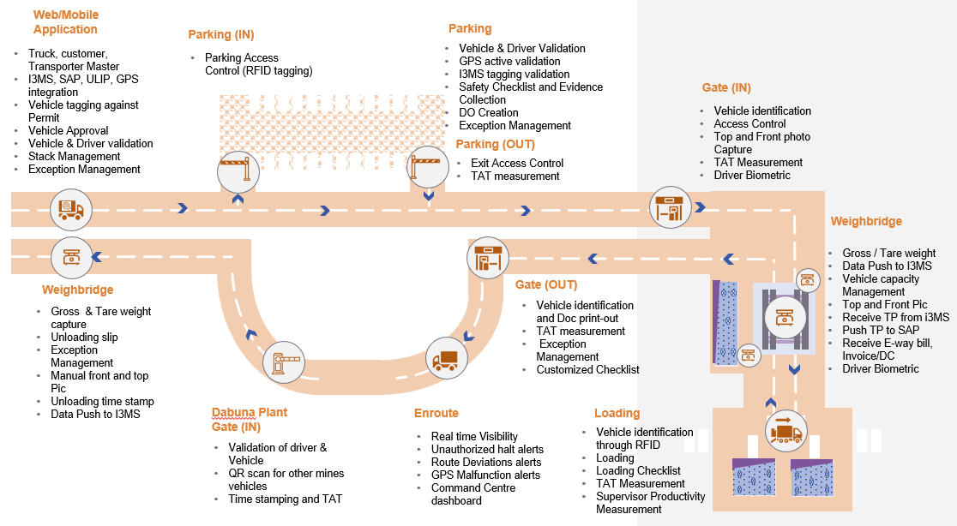

Stagewise Action Points
Below actions will be implemented for all the checkpoints in scope.
Checkpoint | Stagewise Actions
Dispatch Planning and Vehicle Tagging | - Truck, customer, Transporter Master  - I3MS, SAP, ULIP, GPS integration  - Vehicle tagging against Permit  - Vehicle Approval  - Vehicle & Driver validation  - Stack Management  - Exception Management
Parking In | - Parking Access Control (RFID)
Parking | - Vehicle & Driver Validation  - GPS active validation  - I3MS tagging validation  - Safety Checklist and Evidence Collection  - DO Creation  - Exception Management
Parking Out | - Exit Access Control  - TAT Measurement
Gate Entry | - Vehicle identification through RFID  - Access Control  - Top and Front photo Capture  - TAT Measurement  - Driver Biometric
Weighbridge | - Gross / Tare weight  - Data Push to I3MS  - Vehicle capacity Management  - Top and Front Pic  - Receive TP from i3MS  - Push TP to SAP  - Receive E-way bill, Invoice/DC  - Driver Biometric
Enroute to Loading | - Assistance in reaching the loading point
Loading | - Vehicle identification through RFID  - Loading  - Loading Checklist  - TAT Measurement  - Supervisor Productivity Measurement
Gate Out | - Vehicle identification and Doc print-out  - TAT measurement  - Exception Management  - Customized Checklist
Enroute to Plant | - Real time Visibility  - Unauthorized halt alerts  - Route Deviations alerts  - GPS Malfunction alerts  - Command Centre dashboard
Dabuna Plant In | - Validation of driver & Vehicle  - QR scan for other mines vehicles  - Time stamping and TAT
Dabuna Plant  Weighbridge | - Gross & Tare weight capture  - Unloading slip  - Exception Management  - Manual front and top Pic  - Unloading time stamp  - Data Push to I3MS

Hardware for installations

Hardware List
# | Stage | Hardware | Qty/Unit | Units (Sagasahi) | Units (Thakurani) | Units (Dabuna) | Total Hardware
1 | Parking In | Boom Barrier | 1 | 2 | 1 | 0 | 3
 |  | RFID Reader | 1 | 2 | 1 | 0 | 3
 |  | PA System | 1 | 2 | 1 | 0 | 3
2 | Parking | Industrial Grade Tablet | 2 | 2 | 1 | 0 | 6
3 | Parking Out | Boom Barrier | 1 | 2 | 1 | 0 | 3
 |  | RFID Reader | 1 | 2 | 1 | 0 | 3
 |  | PA System | 1 | 2 | 1 | 0 | 3
4 | Gate In | RFID Reader | 1 | 2 | 1 | 0 | 3
 |  | Industrial Grade Tablet | 1 | 2 | 1 | 0 | 3
 |  | ANPR Camera | 1 | 2 | 1 | 0 | 3
 |  | Boom Barrier | 1 | 2 | 1 | 0 | 3
 |  | Smart Camera | 2 | 2 | 1 | 0 | 6
 |  | LED Display | 1 | 2 | 1 | 0 | 3
 |  | AT Controller | 1 | 2 | 1 | 0 | 3
 |  | PA System | 1 | 2 | 1 | 0 | 3
 |  | Traffic Signal | 1 | 2 | 1 | 0 | 3
 |  | Biometric Device | 1 | 2 | 1 | 0 | 3
5 | Weigh Bridge | Boom Barrier | 2 | 6 | 6 | 0 | 24
 |  | PA System | 1 | 6 | 6 | 0 | 12
 |  | Traffic Signal | 2 | 6 | 6 | 0 | 24
 |  | RFID Reader | 2 | 6 | 6 | 0 | 24
 |  | AT Controller | 1 | 6 | 6 | 0 | 12
 |  | Proximity Sensor | 3 | 6 | 6 | 0 | 36
 |  | Smart Camera | 2 | 6 | 6 | 0 | 24
 |  | ANPR Camera | 1 | 6 | 6 | 0 | 12
 |  | LED Display | 2 | 6 | 6 | 0 | 24
 |  | Biometric Device | 1 | 6 | 6 | 0 | 12
6 | Enroute | Traffic Signal/ Display/ RFID Reader/ Mobile Application |  |  |  | 0 | Hardware depends on the length of the road and activities to be performed
7 | Loading Point | Handheld RFID Reader | 1 | 2 | 2 | 0 | 4
8 | Gate out | Industrial Grade Tablet | 1 | 2 | 1 | 0 | 3
 |  | Boom Barrier | 1 | 2 | 1 | 0 | 3
 |  | ANPR Camera | 1 | 2 | 1 | 0 | 3
 |  | RFID Reader | 1 | 2 | 1 | 0 | 3
 |  | Printer | 2 | 2 | 1 | 0 | 6
 |  | AT Controller | 1 | 2 | 1 | 0 | 3
 |  | PA System | 1 | 2 | 1 | 0 | 3
 |  | Biometric Device | 1 | 2 | 1 | 0 | 3
 |  | Smart Camera | 2 | 2 | 1 | 0 | 6
 |  | LED Display | 1 | 2 | 1 | 0 | 3
9 | Dabuna Plant Gate In | RFID Reader | 1 | 0 | 0 | 2 | 2
 |  | ANPR Camera | 1 | 0 | 0 | 2 | 2
 |  | Smart Camera | 2 | 0 | 0 | 2 | 4
 |  | Boom Barrier | 1 | 0 | 0 | 2 | 2
 |  | Biometric Device | 1 | 0 | 0 | 2 | 2
 |  | Industrial Grade Tablet | 1 | 0 | 0 | 2 | 2

Governance Structure
We have a three-layered approach to Governance
Steering committee and value board: This layer will have the executive sponsor for the project with one-to-one mapping with the AMNS’s Sponsors level management. The team will meet monthly/quarterly to validate and monitor the project progress and take strategic decisions. This layer is the highest level of escalation,
Engagement & project management: This layer provides the project level monitoring and management. They will deal with the day-to-day operation issues and escalations. This layer will be responsible for the project success and excellence.
Project operations & transformation: This layer involves all the members of execution team including Technical SPOCs, functional SPOCs and SMEs. These will interact with the client project team on daily basis and work for the success of the project.
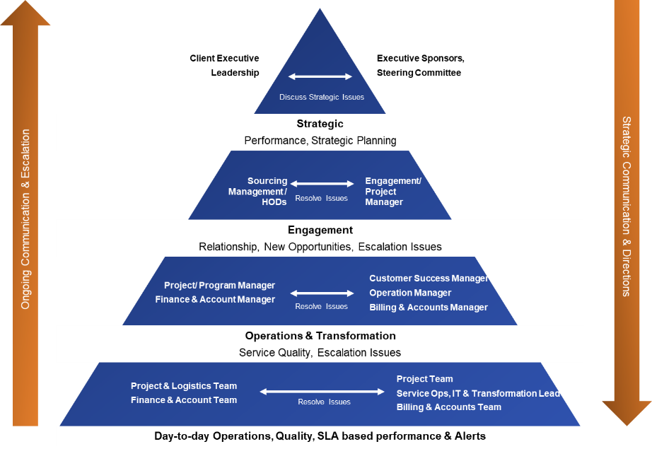

High Level View of Product Roadmap & Innovations Planned
The product roadmap has been built keeping current and future needs of the industry in scope. The roadmap establishes our commitment to the innovations and capabilities which we co-develop with client to ensure these developments are relevant to the needs of the clients.
The intent behind this vision is simple. We understand that “connectivity” is the way for future and hence the core of any solution must embrace the connected part and should support the mechanisms which promotes connectivity.
We understand that while vision is clear, we also need to keep the structural elements flexible and modular. Hence, the design of our architecture and roadmap has been envisioned to be ‘modular and agile’.
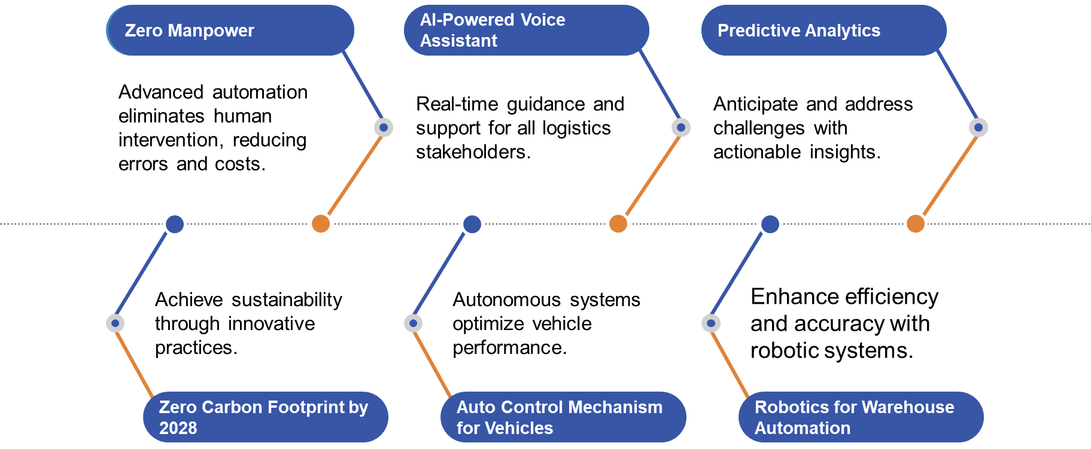

www.axestrack.com

